Teacher Fellowship programme:
The People of 1381

In partnership with
The People of 1381 project

Funded by

How serious was the Peasants’ Revolt?

Andrew Sweet and Rachel Wilson

Teacher notes and activity plan for the Key Stage 3 enquiry: How serious was the Peasants’ Revolt?
Introduction to the resource
The Peasants are revolting! Or are they?
The enquiry presented provides a new narrative of 1381 that champions the voices of those who witnessed the events of that summer. The traditional story – that the rebels marched to London, set fire to the Savoy palace and then were cowed into retreating by the death of Wat Tyler at Smithfield – is not the complete picture. The Revolt was more widespread and far more dangerous, and although the march on London did occur, it was the meeting at Mile End that can be argued to be the crux of the revolt, as Richard II appeared here to grant all the rebels’ requests and to support their cause, in return for an end to violence. Across five lessons, we have sought to expand the lens through which the Revolt is seen, focusing on why it was such a serious challenge to royal authority across the country. As we teach in Somerset and Kent respectively, our enquiry includes a focus on these two stories, but it could easily be adapted – using the resources from the People of 1381 – to include other/many local stories. The enquiry seeks to build an immersive world, through which our Year 7 and 8 students examined the driving forces behind the Revolt from the perspective of those who were involved across the nation.
The resources provided can be used as part of the planned enquiry or adapted for use in varying contexts and to suit other enquiry questions on the late fourteenth century. This enquiry is intended to last five lessons in total and to specifically focus on the experience of people of 1381 from two geographical locations in England. Teachers new to this topic can choose to adopt the Kent or Somerset comparison approach or can adapt the model to their own county or place of interest to make the lessons more meaningful for their context. For example, we would recommend that a study of East Anglia and Essex begin with the database of the People 1381 Project and Juliet Barker's England Arise as a core text to provide an overview. R.B. Dobson’s The Peasant’s Revolt can then be used for primary documents relating to the relevant local area.
Teacher knowledge-updating and context to the enquiry
The story of the Peasants’ Revolt appears to be well known to history teachers, appearing somewhere after the Black Death in most Key Stage 3 textbooks. These usually focus on the early events of the summer of 1381: the ‘march on London’ by a group of raggedly murderous peasants, incensed by high taxes and led by (variably) Jack Straw, John Ball or Wat Tyler.
Telling a new story
So what if we told you that this story wasn’t true? Or, more accurately, that the story was much bigger, broader and more intriguing than this? For a start, ‘Wat Tyler’ may have been a cloak to mask a real name – the equivalent of ‘John Smith’ in the medieval period. He might not have been a real figure. He certainly did not lead most of the people in revolt in 1381. John Ball probably didn’t give ‘that sermon’ (the only contemporary chronicler who mentions it is Froissart, and he begins the ‘quote’ by saying that ‘Ball said things like this at other times’). The ‘marchers’ were much more than a ragged band of peasants; everyone from the peasantry to the minor gentry were involved in this gathering. And, far from ending at Smithfield, with Tyler’s execution, it was the earlier, often overlooked meeting at Mile End that would spark a ripple effect across the country, beginning uprisings in locations as disparate as Bridgewater (Somerset), Beverley (Yorkshire), Derby and Norfolk. After Mile End, people believed that they were settling their grievances with the King’s blessing.
A local focus
We have chosen to focus on Kent and Somerset primarily because that is where our respective schools are. But both offer more than just an opportunity to connect to local history. The Kent story is the ‘old’ story, the story that is well known and familiar. It’s also a really good story, offering a perfect starting point for any enquiry into the Revolt, introducing big names and key events. The Somerset story clearly shows individuals hearing about the unrest in London – there is evidence that Thomas Engilby was IN London when the rebels attacked – taking the news back to their own towns and villages and then acting on Richard II’s apparent order to arrest and execute traitors. So, focusing on events in Somerset is a great way to show not only how widespread the Revolt became, but also how organised the rebels were and how word travelled about rebellion. Other case studies like Beverley, Ware or Derby offer the same opportunity.
Uprisings were different in local areas – indeed, many dealt with particular local concerns – but there were common themes that demonstrate that this was a co-ordinated, organised and deliberate revolt. Contemporary scholarship has led to different perspectives on the events of the summer of 1381, and even a different understanding of the fourteenth-century world in which those caught up in the Revolt lived, loved and worked. By comparing what the rebels DID in each place, as well as whom they attacked and who they WERE, it is possible to see the bigger picture and to understand the commonalities between the grievances expressed. It is also possible to see the specific – such as in York – where the opportunity of wider unrest was seized in order to settle more personal scores or resolve local issues.
A classic approach in the Key Stage 3 classroom has been to focus on the causes of the Revolt. We have moved away from this to develop an enquiry focused on the COMMON PEOPLE themselves and what their actions – and reactions – reveal about their thinking and understanding, and to bring them into the classroom.
There is an abundance of literature explaining that personal stories are most effective in enabling students to understand the actions of people in the past, and it is a rare history teacher indeed who has never experienced the power of the story to capture and inspire students. So this is where we started: with the stories, both the familiar and the less so. From here, we aimed to build the world of the Peasants’ Revolt – to challenge students with the complexity of the events, but ultimately to show them that the medieval ‘peasant’ was not a fictional creature, but was a real, living person, with cares, concerns and worries about their government, their taxes and their future, with human concerns that we can relate to and that we think about in our society today.
So… are you sitting comfortably?
Following in the footsteps of the 1381 Somerset revolt
The Kent story is familiar to teachers, but the Somerset story less so. How do they connect? It is important to note that there does not seem to have been a single individual or group of rebels who were present at the beginning, middle and end of the 1381 Revolt. The People of 1381 database work has not found a witness to all the events. The fragmentation of the evidence means that we have to try to fill in some narrative gaps and construct history with what we have. Thinking about what Christine Counsell calls ‘centres of gravity’ in the narrative, we realised that our Kent and Somerset stories interlink at Mile End. The Kentish rebels might very well have released the two Somerset prisoners and travelled with them to Mile End to hear the King’s proclamations. This is not a shot in the dark – more a real possibility, as they both returned to their counties satisfied that their grievances had been met. This conceptual leap into the unknowable part of the story enables us to pick up two days later in Bridgwater. The town is a local centre of gravity for the Somerset revolt.
During the HA Fellowship residential in Oxford, one of our academic colleagues introduced us to the revolt in Bridgwater. Andrew took up the challenge when a colleague said, ‘Bridgwater to Ilchester, that’s not far Andrew, you could run that.’ The run followed in the footsteps of the rebels and retraced the journey that they would have taken. Ian Mortimer, in his non-history book Why Running Matters, puts it succinctly that long-distance marathon running ‘is not about running... it is about the challenges we face and how we measure up to them’. Andrew was intrigued to see whether travelling across Somerset to Ilchester was achievable. On that summer’s day in 1381, could the two rebels have realistically travelled there and back? That is, were the records of their exploits plausible? That plausibility mattered.

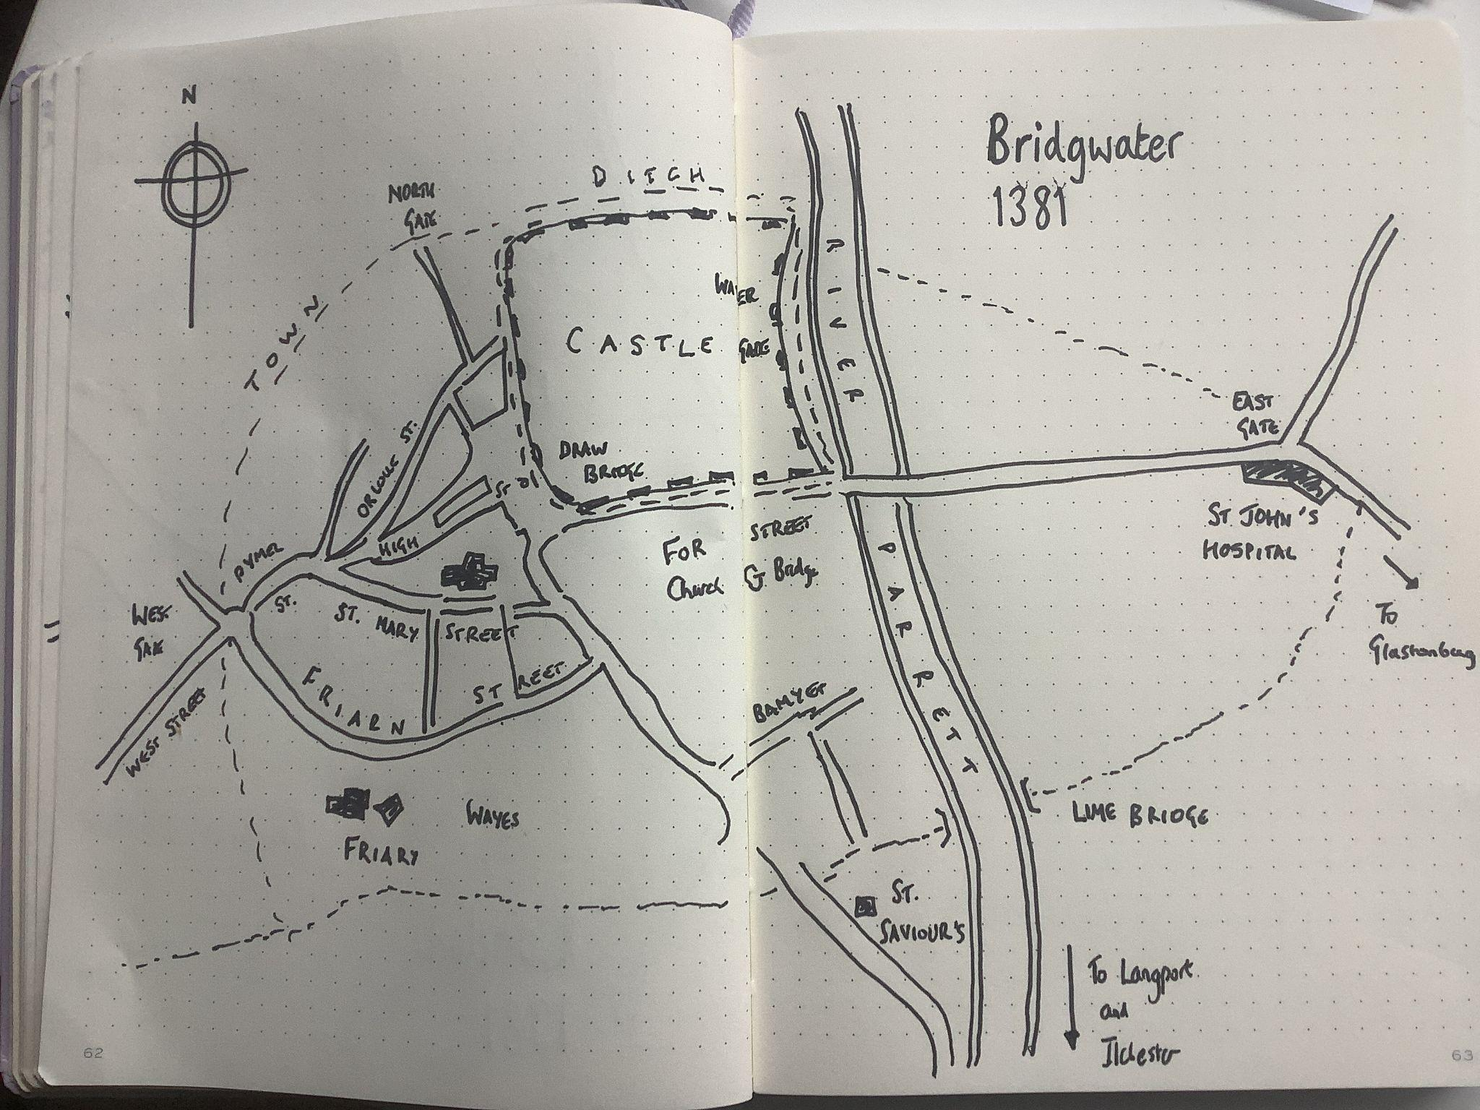
The first task was to identify the route that Thomas Engilby would have taken on Friday 21 June, using the Patent Rolls cited in R. B. Dobson’s The Peasants’ Revolt of 1381 and local knowledge to track the distances and get a sense of the place. Christine Counsell defines ‘centres of gravity’ as historical places of significance – a significance that emanates outwards. Bridgwater, and more specifically St John’s Hospital, was the epicentre of the Somerset part of the Revolt.
Figure 1: Bridgewater in 1381 drawn by Andrew Sweet.
Starting at the easterly gate on Fore Street closest to the castle, at rush hour, the journey proceeded along the river Parrett, following Roman roads and footpaths in the direction of Langport. This mapping required an element of hypothesis about the most probable route, created by connecting the fragments of the evidence from the pardon of Thomas Engilby and local knowledge. We can be sure, but not certain, that he would have travelled by horseback. The distance was run with no tracking device to make this as authentic as possible. Instead, the spires and a church tower along the route, shown on the Gough Map, were used as a guide, and so was the river Parrett. Some private property signs forced detours and the inevitable few miles of getting lost. At key points of interest, Andrew recorded vlogs using a hand-drawn Bridgwater medieval map and an ‘onsite’-to-camera commentary designed to be one take and delivered directly to the class on location. Stopping at Burrough Bridge, Langport, Long Sutton and Ilchester allowed time to rest and regroup, as Thomas would have needed to do. At Long Sutton, the Pardon Rolls say that John Bursy was forced to join Thomas, as he was living in Thomas’s house. It was John who confessed to ‘seizing Hugh Lavenham who was lodged in the gaols there as a man indicted of felony’. The edited vlogs are now short films that can be used to help to answer some of the specific local contextual questions. It is easy to get lost in local detail and lose the bigger picture. We adopted a ‘less is more’ attitude to keep the focus. Students from Kent needed to know the story of the Somerset vendetta in order to identify similarities and differences, but they did not need to know it in huge detail.
THE ENQUIRY
The starting point for our work was to craft an enquiry question in tune with contemporary scholarship, in order to investigate an event that was a singularly dangerous moment for the powerful in English history. ‘How serious was the Peasants’ Revolt?’ provides an opportunity to look at the events in a national and local context. The first lesson sets the scene in Kent, followed by a separate lesson with a broad geographical focus on Somerset and the wider Revolt. A third lesson teaches what the rebels actually did, informed by a research task in which students connect the events of 1381 to the wider fourteenth-century context (the Black Death and Hundred Years’ War), before a fourth lesson focuses on the role of John of Gaunt as an intersecting point for all the rebels. Answering the enquiry question as an essay then allows students to show a nuanced understanding of the Revolt as a whole, acknowledging the variety of people involved, as well as the widespread nature of the threat and the common themes that bound the rebels, while also showing that there were fractures and local concerns that maybe limited the overall impact of the events.

Resources provided:
Many of these are linked or illustrated here, but the full list of resources to support this enquiry is as follows:
- A PowerPoint covering key questions and resources for the whole enquiry
- A folder containing all the lesson resources needed for the enquiry, for use and adaptation as needed
- A map of the events of 1381: https://padlet.com/ha1381/1381-revolt-map-bnofracmmfti1cyc
- A video link to TMHI 2022, in which historian Helen Carr gives an answer to the question ‘How serious was the Peasants’ Revolt?’
Lesson 1: The ‘traditional story’
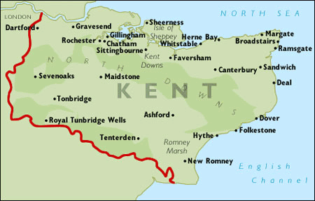
For teachers who are new to the topic, the Peasants’ Revolt began as a tax revolt in Fobbing, Essex. A group of villagers attacked and killed a member of the King’s Commission to collect the third poll tax levied in five years. Word of their actions quickly spread across Essex and across the Thames Valley to northern Kent, where further uprisings began to take place. These then gathered momentum, and larger groups of rebels – from all walks of life – began to move intentionally across the counties, making their way to key administrative centres. In Kent, this was firstly Rochester, where the gaol was broken open and land-ownership records were burned, and then Maidstone, where similar actions occurred, and on to Canterbury. From Canterbury, a large group of rebels, emboldened by the lack of authority, marched to Blackheath, south of London, where they camped and demanded a meeting with the King. At the same time, rebels from Essex were arriving at similar camps on the other side of the river. Richard II initially agreed to a meeting and made his way down the Thames to meet with the rebels. But his advisors with him in the boat were terrified by the number and menace of the rebel camp and refused to allow Richard to land. Incensed, the rebels overran Southwark, opening the infamous Newgate Gaol and setting fire to Lambeth Palace, before attacking London Bridge and forcing their way into the city. Inside, they joined with London rebels and rebels from all over Essex, Hertfordshire and Cambridge. They ran riot, looting and setting fire to John of Gaunt’s Palace of the Savoy. Forced to meet with the rebels at Mile End in a bid to end the chaos, Richard II made an extraordinary intervention when he acknowledged the grievances of the rebels and agreed to allow them to attack ‘traitors’ wherever they found them.
Figure 2: Key points of the rebellion in Kent.
Image: www.britishservices.co.uk/kent.htm
Here is where the ‘traditional’ narrative needs to be left, because it is not those who stayed and attacked the Tower of London that matter for this enquiry. It is those who LEFT – pardon from the King in hand and with Richard’s own banners going with them – who took word of what had happened to the counties. Essex, geographically closest, reignited. John of Gaunt’s representatives in Norfolk and Derby were attacked and, in some cases executed – although Leicester, seat of his power, stayed quiet. In Yorkshire, word of Richard’s assent to the rebel demands also sparked a series of local uprisings to settle grievances specific to this area. Word of the Revolt reached as far as Bridgwater in Somerset, where a more personal grievance was resolved.
So, to introduce the first lesson, ask students what makes an event/incident ‘serious’ – what does it mean to them? You could give the example of a student forgetting their homework – was this serious? What would make it more serious? Encourage students to think about things like regularity (is this a student who never has their homework?), how widespread this is/was (one student or half the class?) and the outcome (was this a flipped homework, which means that said student now can’t access the lesson?).
The concept of ‘how serious’ at the heart of the enquiry question is tackled in three ‘strands’. Have students create a ‘front page’ in their books for this enquiry, where they can add their responses over the series of lessons. They can create a mind-map with three strands: number of people involved (more = more serious), how widespread the revolt was (wider = worse) and the nature of the actions of the rebels (the outcome for those in charge – more action needed worsens the revolt).
To gauge any prior understanding/general misconceptions in the room, ask students to give their gut reaction – without knowing anything about the Revolt or the events of 1381. I had a range of answers, but what was pleasing was the underlying understanding of fourteenth-century power dynamics that was revealed. Some students initially said, ‘Well, they were just peasants, so it can’t have been that hard to manage.’ Very quickly, such comments were shouted down by others, who said, ‘but if PEASANTS are prepared to revolt, it must have been really bad’ or ‘but there are LOADS of peasants – they easily outnumber the people at the top’. Eventually, we settled on a working hypothesis to test: that the Revolt was quite serious, but possibly pretty easy to resolve.
We started with the ‘traditional’ story, as told in most textbooks. You could use a number of different textbooks, having students cross-reference the details discovered to ‘build’ a storyboard of the key events. Alternatively, you can create a set of timeline cards (see Figure 3) for students to sort and then record the narrative. We also found that it was extremely useful to have the overall timeline displayed somewhere so that students immediately have a reference for future lessons.
30 May 1381: Attempts were made to collect a poll tax in Essex. The tax collectors were attacked. | Revolt spread across Essex as peasants attacked local lords, burning manor houses and, where possible, killing the owners. | Some peasants began to attack abbeys and the monks who lived within them. | At the same time, some rebels in Kent gathered at Maidstone, where a preacher named John Ball was imprisoned.
The Kent rebels began to make their way towards London. As they went, they opened prisons and burned administrative records. | 13 June 1381: The Kent rebels reached London. The gates were opened by some poor Londoners. | Their first target was the Palace of the Savoy – the house of the King’s uncle, John of Gaunt. The house was blown up and valuables thrown into the river – but a man caught stealing silver was beheaded. | By 6 June 1381, both Kent and Essex were out of control. Under their leader, Wat Tyler, the Kent rebels had taken over the castles in Rochester and Canterbury.
The 14-year-old Richard II hid in the Tower of London, with his closest advisors, the Archbishop of Canterbury (Simon Sudbury) and his treasurer, John Hales. He watched as the rebels burned houses and murdered lawyers and foreign traders. |  | Friday 14 June 1381: Richard agreed to meet the rebels at Mile End, just outside London. The rebels came, and although they shouted abuse at him, Richard listened to their demands – the highest wages possible and no more poll tax – and, amazingly, he agreed.
Figure 3: Timeline card sort

Those familiar with the roadways of Kent could use the line of the M2 to illustrate the route taken, but at this point it is important to emphasise that the rebels were moving AWAY from London – and quite deliberately so. Both Rochester and Maidstone gaols held prisoners who had been arrested for failing to pay their taxes. Maidstone and Canterbury were the major administrative centres of the county, where the records were held. Canterbury was also the seat of Archbishop Sudbury – not only an extremely unpopular landlord (much land in Kent was owned by Canterbury Cathedral) but also one of the men high up in the court and held responsible for the hated poll tax. By emphasising these points, even the traditional story becomes more nuanced than simply a rag-tag band of peasants, attacking anyone and everyone in their path.
From Canterbury, SOME rebels did indeed march on London (this time following the route now followed by the M20) to arrive at Blackheath. However, the vast majority stayed away, either returning to their homes or waiting in the towns already ransacked. This matters, because the attack on London was – it appears – primarily carried out by Londoners, with rebel bands travelling in from the countryside with particular targets in mind (see the band from Ware, who deliberately travelled down to ransack the Savoy Palace). After these targets were destroyed, the rebels agreed to meet with the King at Mile End.
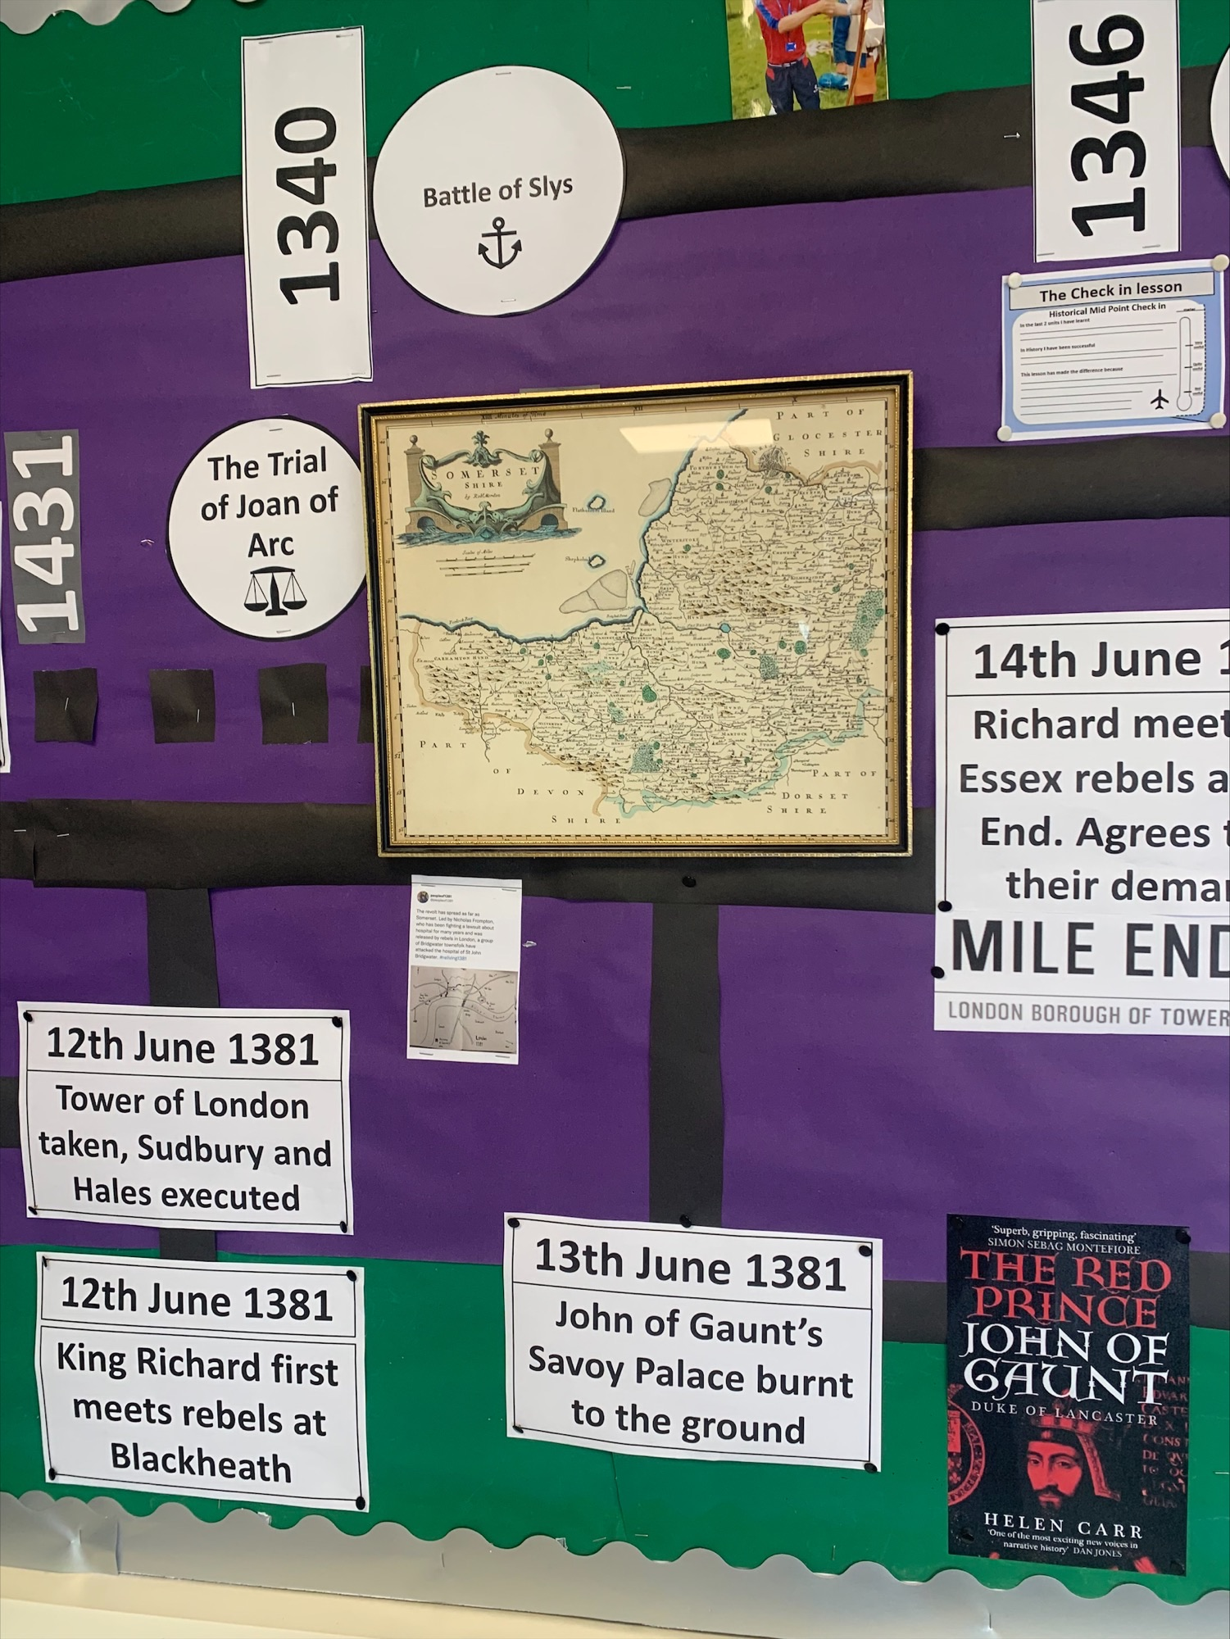
Figure 4: The display board charting the ‘new’ narrative of events in June and July 1381
Once students have the basic timeline/storyboard, stop the narrative. A teacher-led class discussion should then follow, returning to the issue of how ‘serious’ the Revolt was. At this point, students should be reminded of the earlier discussions about what makes a revolt serious. They should be able to complete the first branch of their mind-map on the enquiry front sheet: how many people were involved? At this point, you could provide a sentence guide for all students, allowing them to focus their thinking on ‘serious’, rather than worrying about how to write it down. For example, you could use the sentence: ‘Numerically, the Revolt was ______ serious.’ A class discussion about what could fit in the gap (fairly/very/substantially, etc.) would support thinking and reasoning further. Students can then add two or three bullet-point reasons explaining their choice.

Lesson 2: Geography
Central to this enquiry is the focus on events outside of the traditional narrative. The story of the Kentish rebels is a useful starting point, both for familiarity and – for people in Kent – for local history, but this is not the end of the story, and failing to go beyond these events paints a one-dimensional, oversimplified view of the Revolt. What follows, then, is an attempt to embrace the complexity that followed the meeting with Richard II at Mile End. There are two options here:
The map of events of 1381
This is particularly useful for teachers who are interested in a selective number of locations. Choosing four or five locations provides a wider cross-section of ‘experiences’ across the country.
Begin the lesson by projecting the map onto the whiteboard. Don’t zoom in at this point; give students a few minutes to look at the whole thing. If asked, clarify what the colours mean (in relation to a timeline produced in Lesson 1). Ask for any observations/comments. Students are likely to notice that there were events ‘all over the place’. They may ask why nothing happened in the North West or why there was less activity in the Midlands when compared to Norfolk, Suffolk and Essex. Tying this discussion back to the enquiry, ask for a gut reaction as to what this means in terms of the ‘seriousness’ of the Revolt. Encourage students to consider that there were uprisings across much of the country, as well as the fact that most of this took place after the Mile End meeting on 14 June.
The next stage of the lesson is easiest to undertake if there is access to laptops or Chromebooks. Give all students a blank map of England and have them stick it into the centre of a double-page spread of their exercise book. This will be annotated with the key events from certain places. Ask students to research from the map of events of 1381 and find answers to address the following two questions, modelling the activity using the Kent rebels:
- Can you give a brief outline of what happened? (Rebels attacked goals, moved to administrative centres and burned records, before moving to London and meeting with Richard II)
- Who was targeted in this outbreak? (Key instigators of the poll tax and those responsible for keeping records).
- Having modelled this for the Kent rebels, students then open the map on their laptops and annotate their maps for at least three further locations. For example, Yorkshire and Bridgewater could be compulsory, and then students could choose either Derby, Ware or Bury St Edmunds. These selections are based on giving students a wide geographical range (Kent, Yorkshire and Somerset demonstrate the furthest reaches of unrest) while also allowing students to spot the patterns (all examples are similar, in that grievances were often directed at John of Gaunt or the Church, but that many of these were local in nature, operating under a wide umbrella of unrest at the way in which the country was being governed).
Stories of 1381
If students do not have access to laptops, the activity could be completed using the ‘stories’ of the individuals that were developed from the profiles on the ‘People of 1381’ website. The same task could be used either in carousel form or by having students read one story and present back to the rest of the class.
This lesson concludes with a return to the enquiry question and the completion of the second branch of their mind-map about how widespread the Revolt was. Again, you can use a class discussion based on completing the sentence ‘Geography made the Revolt ___________ serious’ as a starting point. Students then add their reasoning in note form as before.
Key outcomes from this discussion are likely to be:
- There were a wide range of locations in which the Revolt took place, especially beyond London/the South East.
- The rebels rebelled in different ways, according to where they were in the country.
- There were similarities between the nature of these attacks – John of Gaunt’s lands/officers or attacks on Church property
- BUT there were local grievances that were also addressed, under the ‘umbrella’ of justice/righting of wrongs.
Higher-achievers could be encouraged to consider counter-arguments at this point: yes, the Revolt was widespread, but there were significant ‘holes’ in the map – does this lessen the severity? What about the ability of Richard II to use a ‘divide and conquer’ mentality to overcome the localised outbreaks (or even the fact that many of them fizzled out when the initial grievance was dealt with, as in Bridgwater, where they were one of six towns that was refused a pardon)?
Lesson 3: Actions
To start this lesson, return to the enquiry question front page. With two of three branches complete, how serious do students now think that the Revolt was? Is there any movement from their initial gut response from Lesson 1? Probing questioning about reasoning – especially of those who have moved – should give a clear indication of any misconceptions or misunderstandings, and these can be dealt with at this stage.
Then have students return to the map/people from Lesson 2. What patterns can they spot – who or what was being regularly targeted across the country, despite more local grievances? Draw their attention to the regularity with which land belonging to John of Gaunt or the Church was attacked. From here, ask who/what WASN’T attacked, with the answer, of course, being Richard II himself. Point out that this is a bit odd to our minds – surely the King was the reason why everything was going wrong? Ask students to speculate on why Richard wasn’t attacked. Answers might include ‘he was only 14 and not ruling for himself’, ‘the rebels thought that RIchard was on their side – he’d agreed to meet with them, and it was his ADVISORS who took him away’ or ‘it was a big deal and dangerous to oppose a king’. At this point, you can remind students that John of Gaunt, the King’s uncle, was ruling on his behalf at this point, and that it was Gaunt who had demanded more money for the Hundred Years’ War.
You could also have students identify that the Church TEACHINGS were not really attacked in the Revolt – the inflammatory sermon from John Ball almost certainly did not occur. They were attacking the LANDS and WEALTH of the Church – its earthly power. This is a useful nugget for students to store away and revisit when assessing the sixteenth-century Reformation, potentially.
This sets up the research task, which constitutes the rest of the lesson (see Figure 5). At this stage in the enquiry, more background knowledge is needed to make sense of what the rebels were doing and why they were targeting particular individuals. Unless students already know about the Hundred Years’ War, the reason for high taxes and the resentment of John of Gaunt won’t make any sense. Similarly, knowing that the Statute of Labourers (1351) restricted wages and the sumptuary laws of 1363 regulated what colours and cloth could be worn by all people explains why there was general disgruntlement with an out-of-touch ruling class.
Figure 5: Research task for Lesson 3
How serious was the Peasants’ Revolt?
Lesson 3. What did they WANT?

1. What was the STATUTE OF LABOURERS (1351)?
2. What were the SUMPTUARY LAWS (1363)?
3. Why would the peasants be unhappy about these (unprecedented) laws?
4. What was the HUNDRED YEARS’ WAR? When did it START? What was it ABOUT?
5. How well was the War going for England between 1370 and 1380?
6. What was the IMPACT of this on the PEASANTS?
7. What was the POLL TAX?
8. Why did the POLL TAX push lots of peasants OVER THE EDGE?

You may find the following a useful starting point: www.bbc.co.uk/bitesize/topics/z93txbk/articles/zyb77yc. Any further research needs to be CHECKED by using at least ONE other website to confirm the details. As ever, please do NOT use Wikipedia.

Pull together the research task by asking students whether they now understand why John of Gaunt was targeted; focus on his involvement in the failing campaigns of the Hundred Years’ War and the fact that he was seen to be an ‘overmighty’ figure at the heart of a government that was interfering in people’s lives in a manner unprecedented in the medieval period (the sumptuary laws and the incessant demands for taxation). Dropping the detail that John of Gaunt was the Duke of LANCASTER and that his ancestral landholdings were mainly in and around Leicester explains why there was relatively little activity in the North West and Midlands.
Richard’s position was doubly protected; he was a boy-king, ten years old on his accession in 1377 (13 or 14 by 1381), so his uncle, Gaunt, was largely held responsible for the government of the country. Furthermore, the position of the King – divinely appointed and anointed to rule – made him pretty unassailable to opponents. It was high treason to attack the monarch. Time and again in the medieval period, the way to attack an unpopular king was to attack his ‘evil’ advisors (John, Edward II, Isabella and Mortimer’s regency for Edward III, and even Edward III himself towards the end of his life, when dominated by Alice Perrers) – and so placing blame on Gaunt’s shoulders and those of his cronies (Sudbury, Hales, etc.) was a well-recognised path to reform in government.
This lends itself to a firm rebuttal of the idea of ‘peasants’ being primitive, powerless and puerile. These were individuals who were familiar with the law, with the government and with how to effect changes; they understood the ‘conventions’ around challenging authority – and they wanted their right to do so affirmed IN WRITING by Richard after the meeting at Mile End. They made him write down not only their pardons but also their right to attack ‘traitors’ who were undermining his government.
Finally, return to the enquiry front page again. The final branch of the mind-map can now be completed: ‘The actions/targets of the rebels made the Revolt _________ serious’. Key considerations this time include:
- Targeting the King’s UNCLE – a member of the royal family and a man of immense wealth – was a pretty serious issue.
- The disruption to funds during a period of major international conflict – particularly one in which the English were doing badly – could have led to very serious ramifications (including a French invasion of the South Coast).
- Attacks on the Church – even if it was just in terms of wealth – were a pretty huge deal.
- The destruction of records and breaking open of gaols – as well as more general looting, murder and destruction – was a very serious challenge to the authority of royal officials.
Again, the higher-achievers can be challenged to build the counter-argument into their reasoning: the rebels may have challenged Gaunt and attacked Church PROPERTY – but did they call for fundamental reforms of either government or religion? Not that we’ve yet convincingly uncovered. The radical groups who DID push Richard further after the Mile End meeting – the ones who broke into the Tower and executed Sudbury and Hales – were fundamentally defeated at Smithfield, sparking a major pushback from the surviving government officials against the rebels, with those on both sides executing what they believed to be the will of the King.
Lesson 4: Bringing it all together using Helen Carr’s The Red Prince
In this fourth lesson, students apply their new knowledge to the enquiry question by looking at how serious the Revolt was to John of Gaunt. Students are asked to engage with the latest scholarship and to precisely explain how calamitous the Revolt was for the people central to the events. John of Gaunt acts as a counterweight to the rebels and provides students with an individual who arguably is a cause, a protagonist and integral to our challenge to the traditional narrative. It is also a brilliant story that places John of Gaunt back into the narrative and acts as a vehicle for understanding the seriousness of the rebellion in June and July 1381.
At a Chalke Valley History Festival, Helen Carr gave a talk on John of Gaunt. She described the world of 1381 much like a Shakespearean play, with all the big players centre stage and John of Gaunt ‘in the wings’. So why should we care about John of Gaunt? This topic is also addressed in the film provided here: www.youtube.com/watch?v=jUX1E_FG1vI (at 5:14:50). The film is accompanied by a guided reading task, which uses extracts from Carr’s book The Red Prince. Use these first. They build through the questions to have students consider why Carr believes the Revolt to be serious. To bring this task together, ask students what they think that Carr would say if she was asked that question directly. Then tell them that a teacher has asked her this very question – a perfect way to get an actual historian ‘into’ the classroom. After playing the interview clip a first time, ask students whether their ideas about what Carr would say were ‘correct’. Then replay the clip and ask students to listen to her reasoning – WHY did Carr say that the Revolt was serious? Unpicking this slowly gives students a brilliant model of historical reasoning. Some higher-attainers may challenge Carr’s interpretation of the events, saying (correctly) that her reasoning is focused on a very narrow set of details and primarily focused on the attack on the Savoy Palace.
Watching the film clip and having the mind-map front sheet gives students the perfect set-up for an essay to answer the enquiry question, written as the conclusion of this enquiry. Begin to draft ideas as a class after watching the Helen Carr clip and using the extracts from her book. Then draw on other learning across the lessons. Work as you need to help students to structure their answers. Then students write their own responses.
Conclusions
This enquiry repositions the 1381 Revolt and reveals a largely forgotten narrative that has been brought into focus by the 1381 Project. The enquiry interprets the events of the Peasants’ Revolt at a pivotal moment in English history, deserving of more detailed attention. It offers a more nuanced approach to the study and understanding of the Peasants’ Revolt, and an appreciation of medieval society, how kingship worked and the ways in which there were checks on their authority. It also connects national and local history and uses the scholarship of the People of 1381 Project to answer a question that focuses on the individuality of the people of 1381.The Peasants’ Revolt is clearly more than simply a by-product of the Black Death. It was multifaceted and affected different groups in different ways. It was so serious that it was remembered long after it ended.
The enquiry promotes a respectful view of the past by enabling the study of individuals in real places. It also promotes a deeper appreciation of the ways in which historians work and why their work matters.
Andrew Sweet and Rachel Wilson

Froissart, J. (1978) Chronicles. Penguin Classics, pp. 211–2.
Storr, W. (2020) The Science of Storytelling. Collins.
Counsell, C. (2020) HA Conference presentation
Mortimer, I. (2019) Why Running Matters: Lessons in life, pain and exhilaration from the 5K to the marathon. Summersdale, p. 4.
Dobson, R. B. (1970) The Peasant’s Revolt of 1381. Macmillan.
Counsell, C. (2020) HA Conference presentation.
Dobson, R. B. (1970) The Peasant’s Revolt of 1381. Macmillan,p. 280.
Gough Map: www.goughmap.org
Dobson, R. B. (1970) The Peasant’s Revolt of 1381. Macmillan, p. 281.

